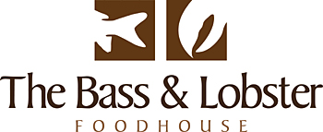
Davy Jones’ Locker Specials

Starters

Oysters, natural with shallot and red wine vinegar -or- tempura with Asian slaw and coconut aioli. 6 for £9.95

Honey, apple cured mullet, tomato and olive salsa, oyster mayonnaise and an apple, fennel and Pernod sorbet. £7.00

Snails in a roasted garlic and parsley butter. £8.95 for 6

Gorey beach razor clam, chorizo and cider Thermidor. £6.95

Hand dived Jersey scallops, fried black pudding, mushroom puree with a walnut dressing and tarragon ice cream. £11.95

Lobster tempura, Asian slaw, chorizo, red pepper and olive dressing. £12.95

Mains

Catch of the day, mussels with an autumn vegetable and potato broth. £15.95

Sea bream fillet, Thai spiced prawn and coconut curry. £22.00

‘The Bass and Lobster’
Sea bass fillet and lobster tempura, cabbage and bacon croquette, carrot puree and lobster cream. £35.00 -or- Just Bass £25.00

‘Steak and Lobster’
Chargrilled ribeye steak and lobster tempura, green beans, veal jus and truffle, parmesan
chips £35.00

Whole poached lobster tail and tempura claws, ‘Three Oaks’ tomato salad, avocado puree and Jersey Royals. £35.00

Please be aware all menu items are subject to availability and may change at the management’s discretion.

